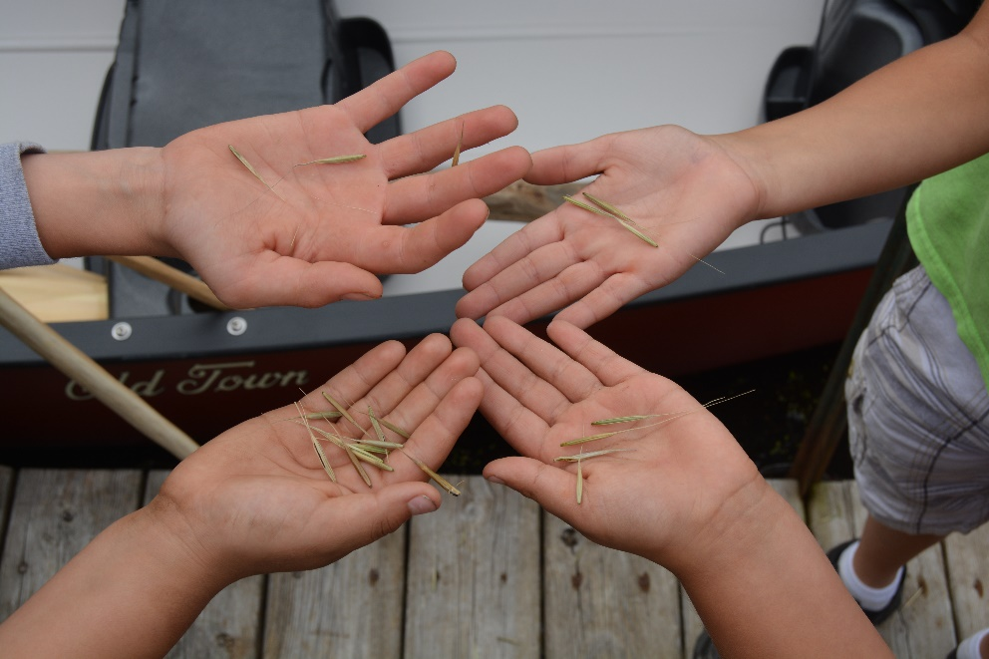

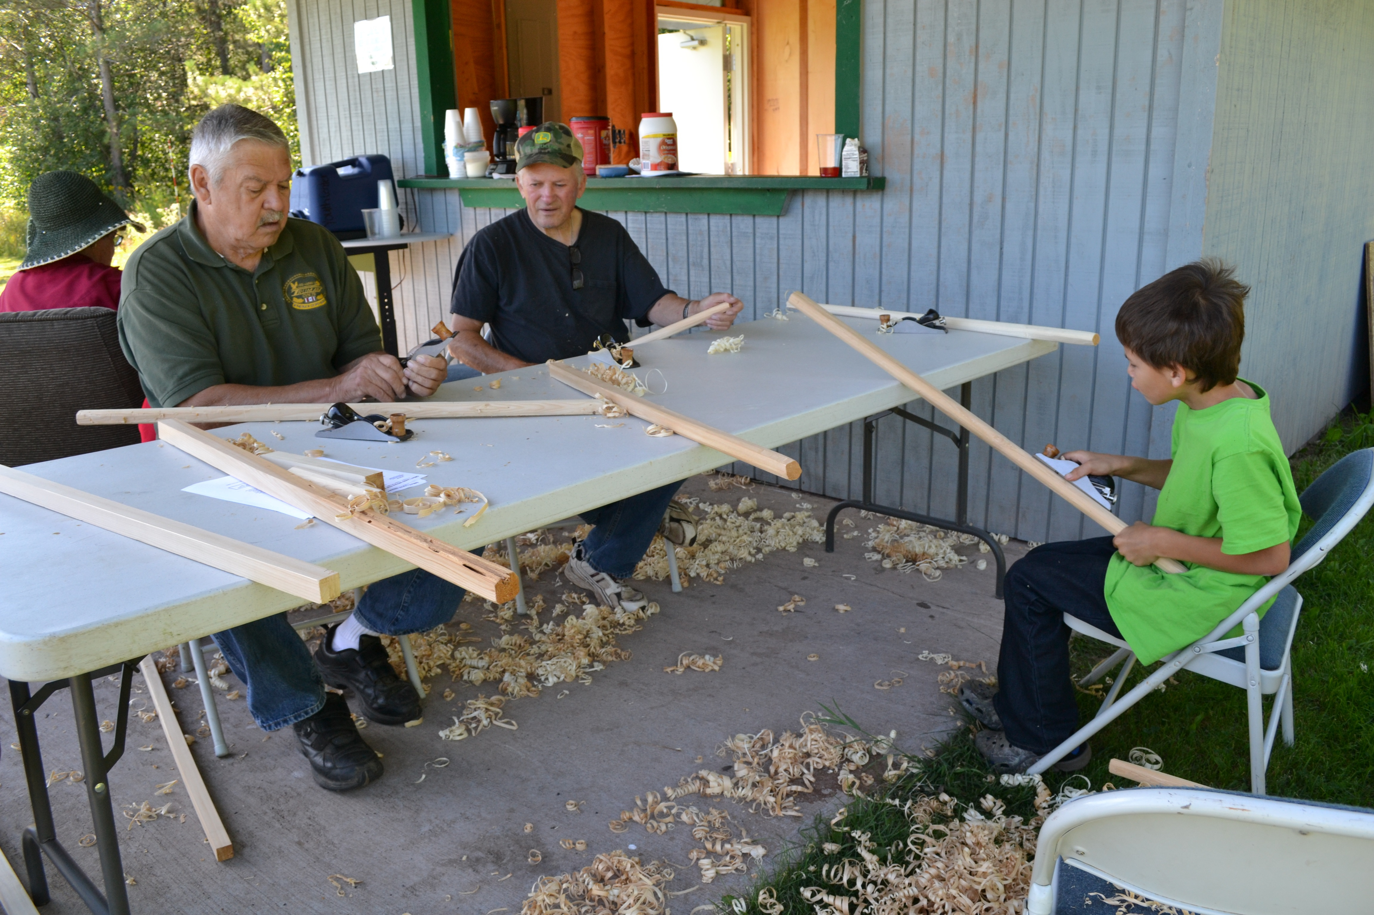
Climate Change Adaptation for Tribes and Tribal Partners

Workshop goals: After completing this course, participants should be able to:
- Identify priorities and set goals for tribal natural resources management projects.
- Evaluate challenges and opportunities to meeting select goals under climate change.
- Develop management actions to help adapt natural resources to changing conditions.
- Develop plans to engage tribal community members in adaptation decisions.
- Learn about tools and approaches that can serve as a foundation for more detailed local and regional work.

AGENDA
June 3: Building the Foundation
8:30 Arrival & Registration

9:00 Welcome and Introduction
Opening prayer and welcome from the hosts

9:30 Introductions
Participants introduce themselves
Photo ice breaker

10:00 Guiding Principles – Discussion and Activity
Including tribal perspectives and values in natural resource stewardship.

10:45 Break

11:00 Tribal Adaptation Menu Tour
Walk through the ideas in the Tribal Adaptation Menu and discuss with the whole group

11:45 Lunch (provided)

12:30 Refine Project Goals and Objectives
In small groups, discuss project goals and objectives.
Share project ideas with the larger group.

1:15 Assess Climate Change Impacts – Small Groups
Discuss and prioritize climate impacts at the scale of your project (Adaptation Workbook Step #2).

2:00 Climate Change Impacts – Large Group
Group activity and discussion

2:30 Break

2:45 Challenges/Opportunities for Management Objectives – Presentation and Small Groups
Presentation of Adaptation Workbook Step #3.
Describe how climate change affects the feasibility of your management objectives

3:45 Challenges/Opportunities for Management Objectives – Large Group
Group activity and discussion.

4:15 Wrap-up
Final thoughts - participants as well as facilitators.

4:30 Done for the Day!

5:30 Dinner (optional)
Pickles, (906) 248-7000, 11204 W Lakeshore Dr., Brimley, MI 49715

June 4: Setting a Path Forward

8:30 Arrive and Get Settled

9:00 Welcome and Recap of Day 1

9:30 Adaptation Strategies and Approaches – Presentation
Provide an overview of adaptation concepts and review the Tribal Adaptation Menu

10:00 Adaptation Strategies and Approaches – Small groups
Select and evaluate potential adaptation actions from the menu of Adaptation Strategies and Approaches (Adaptation Workbook Step #4).

10:45 Break

11:00 Continue Adaptation Strategies and Approaches – Small groups
Continue Step 4 of the adaptation workbook

12:00 Lunch (provided)

12:45 Adaptation Approaches and Tactics – Large Group Discussion and Sharing
Time to finalize Step 4
Project teams create posters and share with the full group to collect recommendations

2:15 Break

2:30 Continue Adaptation Approaches and Tactics – Large Group Discussion and Sharing
Share posters and gather group recommendations.

3:15 Moving Forward: How do we start?
Group discussion on how to start moving adaptation ideas forward.

4:15 Wrap-up
Reflect on the day

4:30 Done for the Day!

June 5: Tying up the Bundle

8:30 Arrive and Get Settled

9:00 Reflections from the Group
Discussion about the process and project ideas.

9:30 Monitoring and Evaluating Effectiveness – Presentation and Small Groups
Discuss monitoring opportunities and ideas (Adaptation Workbook Step #5).
Think about how to engage community in monitoring.

10:15 Feedback & Next Steps
Feedback on Tribal Adaptation Menu and the workshop.
Discuss moving forward on projects post-workshop.

11:00 Closing Prayer

11:30 Lunch (provided)

