Climate Adaptation Short Course for Land Trusts
May 2022 Course
- Course web page
- Registration link
- Adaptation & Land Trusts webpage

Course Learning Objectives
- Understand how climate adaptation and mitigation relate to the goals of your land trust.
- Identify locally important climate change impacts and vulnerabilities.
- Use the quick start guide to adaptation planning for land trusts to consider climate change and carbon in land stewardship and management.
- Develop actions to help your project or natural area adapt to changing conditions.
- Communicate with stakeholders and rights holders about climate impacts and adaptation responses.

Audience
This online short course is designed for land trusts actively working on stewardship projects in rural, suburban, and urban forests, forested watersheds, and wetland systems.
- Land trusts can participate as individuals or in groups.
- Climate vulnerability and management information will be targeted to ecosystems in the Western U.S., however groups or individuals from other regions are welcome to register if space allows.

Schedule At-A-Glance
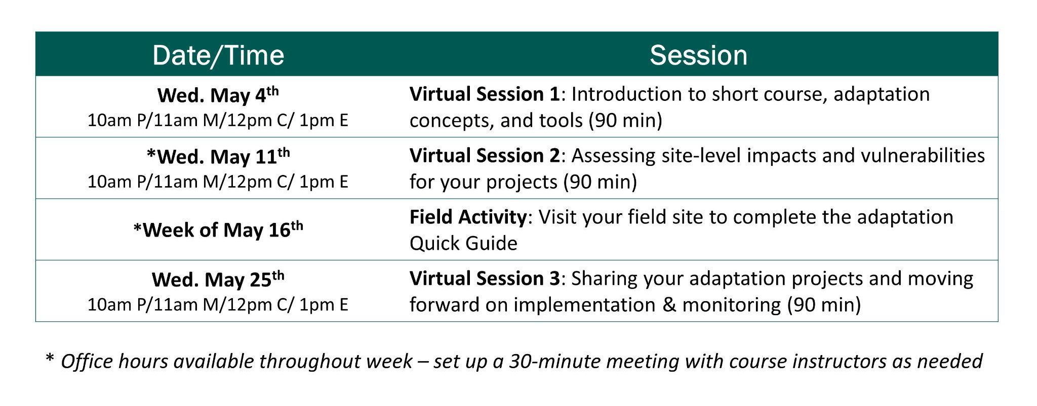

Connection information
Zoom: https://michigantech.zoom.us/j/87836692784?pwd=Ny81bTloZysvY0c0L2h4R2lVempIZz09
Passcode: 4050

Course Contacts
Kristen Schmitt: kmschmit@mtu.edu
Danielle Shannon: dshannon@mtu.edu

Draft Agenda
Session 1 – May 4th: 10am PT/11am MT/12pm CT/1pm ET

Topics:
- Welcome, course objectives, instructors, and agenda
- Activity: climate impacts most relevant to your region
- Introduction to adaptation planning, concepts and tools
- Example(s): Putting it all together: considering climate change in natural resources management planning
Assignment Week 1:
- Read through the Quick Start Guide to Adaptation Planning for Land Trusts.​
- Think about a property/project area you’d like to consider using the Adaptation Quick Start Guide.
Optional/background reading:
- As needed: view education modules on climate change science and modeling, and climate change effects on forests and grasslands (https://www.fs.usda.gov/ccrc/education).
- Look to the Land: Carbon Management in Forests and Grasslands (pg. 25)

Session 2 — May 11th: 10am PT/11am MT/12pm CT/1pm ET

Topics:
- Assessing site-level impacts and vulnerabilities for your projects
- Components of ecosystem vulnerability
- Resources for understanding climate change impacts and vulnerability
- Activity: Discuss the climate impacts and vulnerabilities that are most relevant to your project site
- Tips for picking a property/project area for the week 3 field activity
Assignment Week 2
- Review climate vulnerability resources for your region:
  - Climate Resources - California
  - Climate Resources – Hawai’I and Pacific Islands
  - Climate Resources – Pacific Northwest and Alaska
  - Climate Resources – Rocky Mountain and Intermountain West
  - Climate Resources – Southwestern U.S.
  - Urban Forest Vulnerability – multiple locations
- Select a property/project area to use for your field activity
- Tell us about your plans to visit your field site using this short online form
- Download or print the Quick Start Guide to Adaptation Planning for Land Trusts for your field activity/visit
Optional/background reading:
- Set up an appointment with instructors during office hours to discuss your project. If scheduled office hours don’t work for your group, contact an instructor directly to set up a meeting.
  - Sign up for an appointment time here (link TBD)
- As needed: view module on responses to climate change (adaptation concepts - https://www.fs.usda.gov/ccrc/education).

Session 3 - Field Activity (self-study - no lecture), week of May 16th
Topics:
- Visit your property/project area on your own time

Assignment Week 3
- Visit your field site and complete the worksheets from the Quick Start Guide to Adaptation Planning for Land Trusts.
- Share your location, a picture of your field site and a brief summary of your project here.
- Get ready to share your project information and adaptation ideas during the final session.
Optional/background reading:
- Set up an appointment with instructors during office hours to discuss your project. If scheduled office hours don’t work for your group, contact an instructor directly to set up a meeting.
  - Sign up for an appointment time here (Link TBD)
- Share a copy of your worksheets if you would like feedback from the NIACS team in the month following the course. (Label your worksheets with your name and upload them to this google drive folder (link TBD)). If you have trouble, send us an email!

Session 4 — May 25th: 10am PT/11am MT/12pm CT/1pm ET

Topics:
- Sharing your adaptation projects
- Activity: Tell us about your project and your adaptation decisions
- Activity: condensed storytelling and discussion of adaptation projects
- Moving forward on adaptation actions:
  - Brief intro to monitoring adaptation success (NIACS)
  - Remote monitoring (LTA)
  - Communication & project implementation

Assignment Week 4
- Complete course evaluation (link TBD)

Optional/background reading:
- Share a copy of your worksheets if you would like feedback from the NIACS team in the month following the course. (Label your worksheets with your name and upload them to this google drive folder (link TBD)). If you have trouble, send us an email!
- Land Trust Alliance Communications Guide

